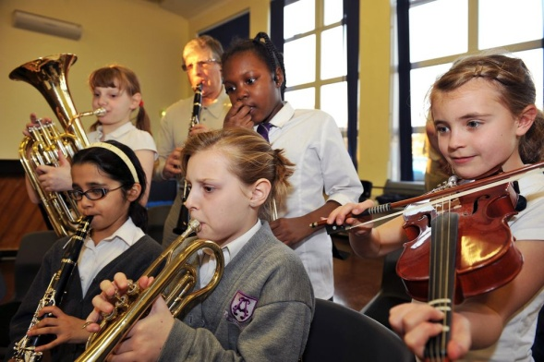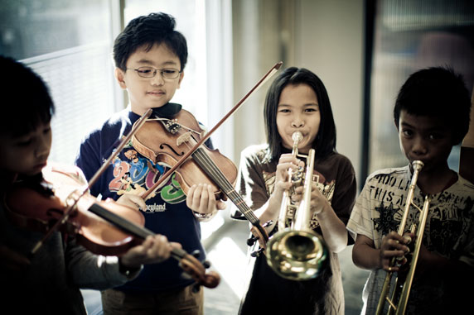
Band and Orchestra
The fifth grade band and orchestra students are beginning to work on music for the winter concert. Pieces are chosen which highlight the various concepts and skills the students are currently working to master.
Fourth grade beginning band and orchestra students have gotten off to a great start and are working hard as well!
All band and orchestra students in 4th and 5th grade will perform at the winter concert.
The winter concert is planned for Wednesday, December 2nd. An afternoon concert will be performed during the day for the students at Berkley School. An evening concert will be performed for parents and the public at New Milford High School Auditorium at 7:00 P.M.

